Use of Application Software and mobile devices to Increase Management Efficiency

ABSTRACT
Lately application programming and cell phones in any association can accelerate the cycles. Many existing models of the individual acknowledgment and execution of data innovation in authoritative settings have been created in the period of "at the workplace" processing like MIS, office robotization, groupware, ERP, CRM, versatile applications, etc. versatile registering in associations. In view of the surviving writing and the contextual analysis information we prepare toward more far-reaching models of the appropriation and execution of versatile innovations in associations
Introduction
These days, cell phones are not restricted just to send SMSs and settle on telephone decisions however they are utilized for various purposes like exploring the web, browsing messages, playing and so forth Cell phones' ability of putting away and handling data has expanded a ton, and distinctive working frameworks have made these gadgets simple to use for nearly everybody, regardless of his/her age or schooling (Bach, 2020) on the other hand computer hardware is basically pointless without computer software. Programming is the projects that are expected to achieve the information, handling, yield, stockpiling, and control exercises of data frameworks (Mejia, 2019)
In this study we shall look on the use of Ms Excel software for capital budgeting analysis. Excel has become an indispensable piece of most business associations across the world. Excel is utilized for different purposes by business foundations. A few associations utilize this accounting page programming for creating reminders, track deals patterns, and other business information.

Figure 1Equity analysis
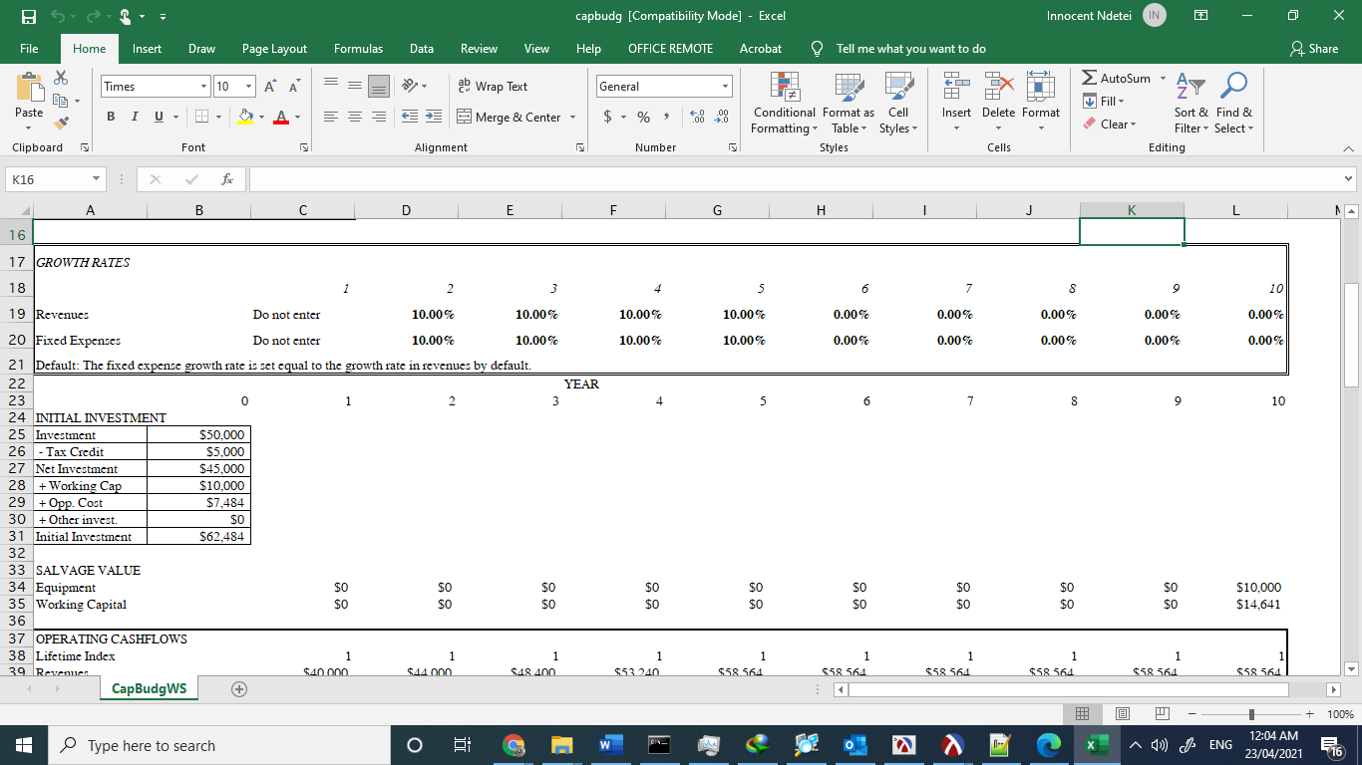
Figure 2 Growth rates in months

Figure 3 initial investment costs

Figure 4 operating cash flows

Figure 5 investment Measures and depreciation
The figures above show a Basic program for doing capital budgeting analysis with inclusion of opportunity costs, working capital requirements, etc
Capital budgeting is the method of evaluating future investments. Construction of a new plant or large investment in an external venture are examples of ventures requiring capital budgeting before being accepted or denied. As part of capital budgeting, a corporation must calculate the lifetime cash inflows and outflows of a prospective project to decide whether the potential returns produced meet a suitable target benchmark. Capital budgeting is also known as investment assessment. Companies use capital budgeting to assess large projects and expenditures, including new plants or machinery. Method involves reviewing cash inflows and outflows of a project to assess if the anticipated return meets a specified benchmark.

Conclusion
Applications and mobile technologies is essential to business operations. Employees—especially millennials—worth mobile tools and apps that help stay informed and efficient. By integrating built-in mobile automation technologies, businesses can redefine how plant employees work, build a draw for the best and brightest, while enhancing operations and production simultaneously
References
International Conference on Digital Economy, In Bach, T. M. A., In Jallouli, R., In Samet, A., In Touzani, M., In Strat, V. A., & In Pocatilu, P. (2020). Digital economy: Emerging technologies and business innovation : 5th International Conference on Digital Economy, ICDEc 2020, Bucharest, Romania, June 11-13, 2020 : proceedings.
Ismaili, J., Ibrahimi, E. H. O., & SpringerLink (Online service). (2016). Mobile learning as alternative to assistive technology devices for special needs students. (Education and information technologies.)
Eman K. Elsayed, Kamal A. ElDahshan, Enas E. El-Sharawy, & Naglaa E. Ghannam. (January 01, 2019). Reverse engineering approach for improving the quality of mobile applications. Peerj Computer Science, 5.
Mejia, J., Muñoz, M., Rocha, A., Peña, A., & Pérez-Cisneros, M. (2019). Trends and Applications in Software Engineering: Proceedings of the 7th International Conference on Software Process Improvement (CIMPS 2018). Cham: Springer International Publishing.

